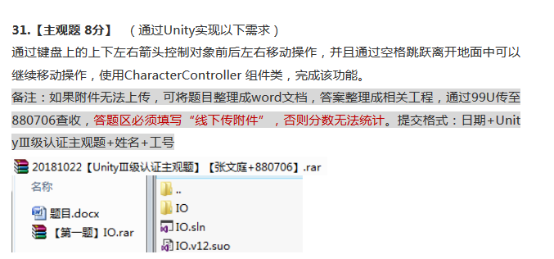

public class playerControl : MonoBehaviour {

private CharacterController CC;

public float moveSpeed = 3;

public float jumpSpeed = 5;

private Vector3 moveDir = Vector3.zero;

// Use this for initialization

void Start () {

CC = GetComponent<CharacterController>();

}

// Update is called once per frame

void FixedUpdate () {

moveDir.x = Input.GetAxis("Horizontal") \* moveSpeed;

moveDir.z = Input.GetAxis("Vertical") \* moveSpeed;

if (CC.isGrounded)

{

if (Input.GetKeyDown(KeyCode.Space))

{

Debug.Log(CC.isGrounded);

moveDir.y = jumpSpeed;

}

}

else

{

moveDir += Physics.gravity \* Time.fixedDeltaTime;

}

CC.Move(moveDir \* Time.fixedDeltaTime);

}

}

